**Simulation in Biology Abstract**

**Group:** Molecular

**Project name:** Neurotransmission Simulation

**Student name:** Daniel McDonough

**Project description:**

Within the cell there are proteins used that are coupled with G protein effector systems. Upon the existence of a transmitter protein in a receptor, G protein is activated, where adenylyl is stimulated. This causes ATP to be converted into cAMP, which intern activates protein kinase A and allows phosphorylation of potassium channels. Changing the amount of transmitter and length of degradation could change the effectiveness of the G protein.

**Agents and rules:**

*Transmitter rules:*

1. Generated at the leisure of the simulation runner
2. When collided to Receptor it attaches for a set time then removes itself
3. 1 transmitter has a random chance to spawn every tick
4. Moves randomly
5. Decays after set time
6. Moves outside of Cell
7. Representation: Yellow Circle

*Cell Membrane*:

1. Representation: Purple Patches
2. Nothing is supposed to pass the cell membrane

*Receptor rules:*

1. When Transmitter is attached, changes color to pink and it’s shape to a more of a bowtie
2. If G-protein is below the activated Receptor it splits into its subparts
3. Has a chance of “burning” after being attached to a receptor for a set time where the color is set to black and is then unable to further interact with transmitters or G-proteins
4. Representation: Red Square with a divot

*G-Protein rules:*

1. Follows along the neuronal membrane
2. If a Receptor is above it where it splits into Alpha and Beta-Gamma subparts
3. Shape: Green and White circles

*Alpha-Protein rules:*

1. Follows the cell membrane
2. When interacted with an ATP charged PLC it changes color to green
3. If a green Alpha protein interacts with a beta-gamma then it forms a G-protein
4. Shape: Blue Circle

*Beta-Gamma-Protein rules:*

1. Follows the cell membrane
2. Shape: White Circle

*cAMP rules:*

1. When a charged PLC and a charges alpha protein collide they produce a cAMP molecule
2. Floats inside the cell
3. cAMP can attach to PKA
4. cAMP is able to degrade
5. Shape: Blue Circle

Adeniline Cyclaze/PLC

1. Obtains ATP over a given amount of time
2. If it has ATP it turns blue
3. Motionless
4. If blue PLC combines with blue Alpha-protein then it produces cAMP
5. Shape: Orange Triangle

*PKA rules:*

1. PKA when cAMP is attached it turns a lighter color
2. Can attach to phosphorylate potassium channels for a set time
3. If attached to a channel it loses its cAMP
4. Normal PKA just bounces around
5. Free floating in the cell
6. Shape: purple box

*Potassium Channels rules:*

1. Have a closed and opened state
2. Start on closed
3. Upon interaction with PKA+cAMP change state
4. Ions move through the channel when open
5. Shape: Pink Squares (closed) black squares (open)

*Other ions:*

1. Can decay over set time
2. Spawn in Smooth ER
3. Have a set chance to spawn each tick
4. Shape: white circle

*Smooth ER*:

1. Representation: Pink Patches
2. Nothing is supposed to pass through it without an activated channel

**Model validation:**

1. If no Transmitters, then no Ions are released
2. If no Receptors, no Ions are released
3. If no Channels, then no Ions are released
4. If no G-Proteins, then no Ions are released
5. If no PLC, then no Ions are released
6. If no PKA, then no Ions are released

**Hypotheses / Predictions:**

1) Decreased decay time of cAMP negatively effects the amount Ions released

2) The amount of transmitters proportionally increases the amount of burnt receptors by the set rate.

**Evaluation (graphs, statistics):**

1. Graphs of the populations of agents over time
   1. Transmitters
   2. Active Receptors
   3. cAMP
   4. Ions Out of the smooth ER
   5. Open Channels
   6. PKA with cAMP
   7. PLC w/ ATP
   8. Burnt Receptors

**User Interaction (sliders, buttons):**

1. Number of Channels
2. Channel Open Time
3. Number of PLC
4. Time it takes for PLC to obtain ATP
5. Number of G Protein
6. cAMP decay time
7. Number of PKA
8. Number of Receptors
9. Receptor Activated Time
10. Receptor Burn Rate
11. Number of Ions
12. Ion Spawn Rate
13. Ion Decay time
14. Number of Transmitters
15. Transmitter Spawn rate
16. Transmitter life time

**Testing:**

Hypothesis 1:

In the two figures below you are able to see a direct comparison between the actions of increased cAMP lifetime and no lifetime. With no lifetime, there has been little to no release of Ions from the Smooth ER or PKA with cAMP where as with a longer life time, cAMP has a higher chance of binding to PKA, which in turn opens the channels for Ions to be released, supporting my hypothesis. Although the data does support my hypothesis more data is still needed to be collected for any definitive proof.

Figure 1 (cAMP-life-time = 0):

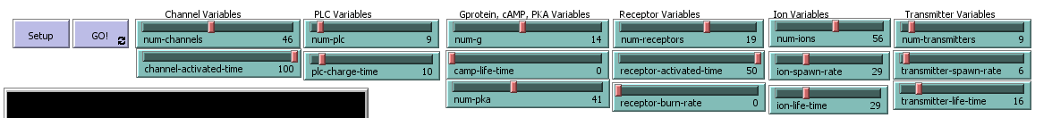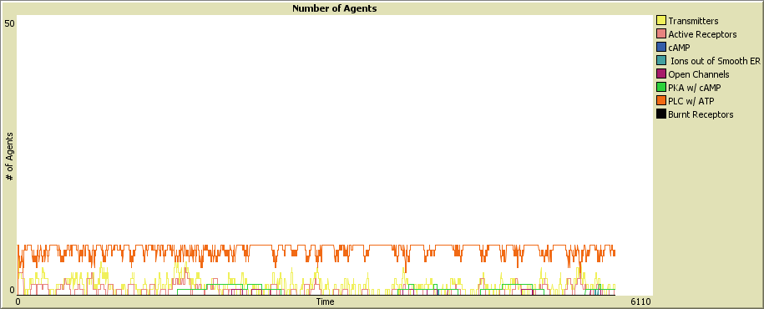

**Figure 2 (cAMP-life-time = 100):**

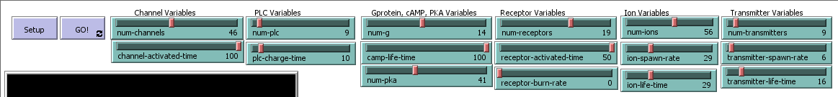

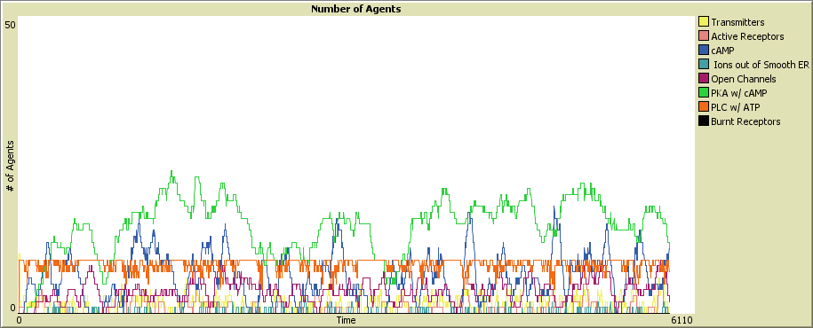

Hypothesis 2:

In the two figures below you are able to see a direct comparison between the amounts of Transmitters with the constant burn rate of 30. It was hypothesized that there was a positive correlation with the number of transmitters and number of burnt receptors over time. As shown in the graphs below it took 6110 ticks for all Receptors to burn with a 10% spawn rate but less than 2000 ticks with a 100% spawn rate. This supports my hypothesis however more testing is required for definitive proof.

Figure1 (Transmitter-Spawn-Rate = 10):

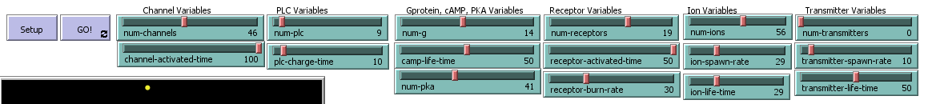

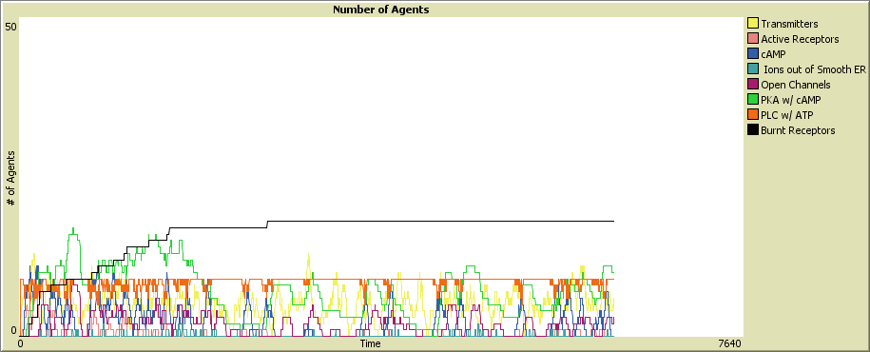

Figure 2 (Transmitter-Spawn Rate = 100):

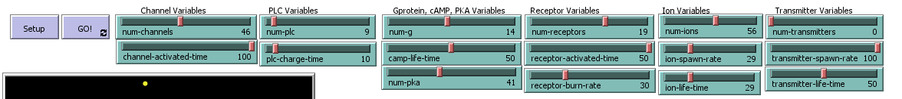

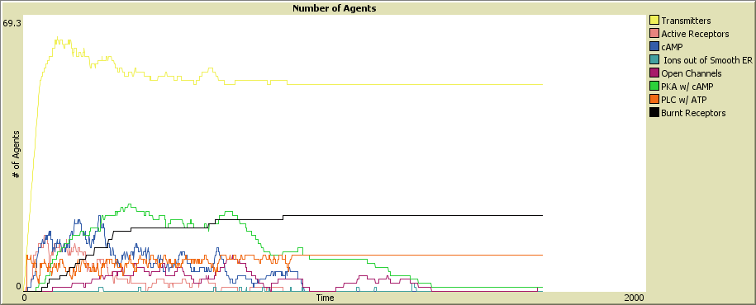

**References:**

<https://bmcresnotes.biomedcentral.com/track/pdf/10.1186/1756-0500-5-608?site=bmcresnotes.biomedcentral.com>

<https://onlinelibrary.wiley.com/doi/abs/10.1111/jipb.12648>

<https://www.youtube.com/watch?v=FD3oksR-bhk>

<https://www.youtube.com/watch?v=V_0EcUr_txk>